Normandale Terminology
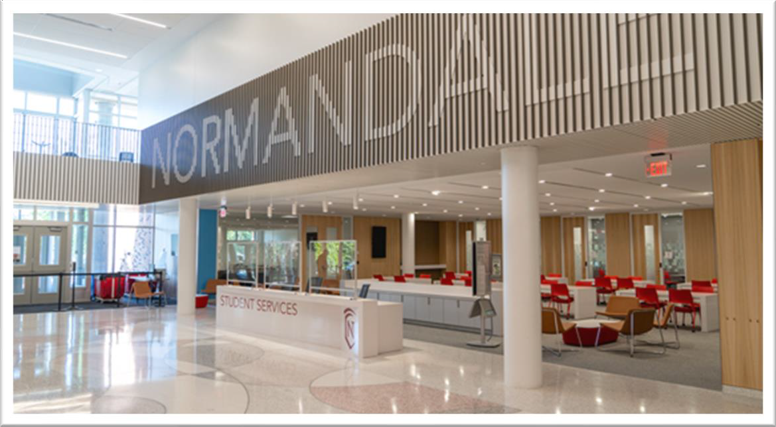

STUDENT SERVICES
studentservices@normandale.edu | 952-358-8100

Who We Are
Student Services provides personalized information and support to assist you with student records, financial aid, scholarships, billing and payments.

Contact Us
Phone: 952-358-8100
Email: studentservices@normandale.edu
Web: https://www.normandale.edu/student-services
*Chat services available on our website

Use this helpful list of Normandale Community College vocabulary
to help you during your academic journey with us!

Academic Advising: Students can meet with advisors for help in course selection and registration, program planning, degree completion requirements, and more.

Adult Basic Education (ABE): ABE placement scores show that students will need to improve their basic skills in reding or writing or math.

Apply: The process by which individuals ask to be accepted as students into the college or program of study.

Asynchronous Learning: Students do not “attend” class at a set place, but rather access course materials on an online platform at a time of their choosing.

Associate Degree: A qualification awarded to students upon successful completion of a course of study in higher education within two or three years. The degree can translate into the first two years of a bachelor’s degree.
Audit: Attending a course without getting a grade for the course. Auditing students are not eligible for financial aid and are still responsible for their tuition.
Book Charging: Allows students to add the cost of their books (used like a credit card), up to $600, purchased at the Normandale Textbook Depot to their tuition and fees bill.
Financial Aid applicants and students who are enrolled in the Nelnet Payment Plan may be able to use book charging.

Campus Store: Students can purchase any necessary school supplies, Normandale gear, food, beverage items and more.

Certificate: Certificate programs are geared towards those who are looking for short-term training who wish to develop vocational skills for entry-level employment.

Completion Rate: You are required to successfully complete a minimum of 2/3 (66.66%) of all courses you attempt. Grades of F, FN, NA, FW, NW, I, N, NC, W, Z and IP (or blank/missing) are NOT successfully completed and thus negatively impact the completion percentage.

Collection Agency: Debts that are 120 days past due can be referred to a collection agency. Collection agencies can assess additional fees to the debt.

Counseling: As a student you may experience a range of life issues that can become barriers to learning. In a confidential setting, our counselors are available for crisis intervention, referrals when necessary, and can provide mental health information and

brochures. These services are offered free of charge to currently enrolled Normandale students.
Course Catalog: Updated each school year, the course catalog contains the list of all courses that are offered within the academic year. It is organized by subject, includes credits awarded, and a summary of each course.

D2L: Desire To (2) Learn, is the online platform for students to access their online courses and coursework. Students login using their Star ID and Star ID Password.

Degree Audit Report: This report helps students identify and understand current academic requirements for degree or program completion. It monitors students' progress by showing what requirements have been met, what is still in progress, and/or what is still incomplete to satisfy the requirement to earn intended degree or program.

Degree-Seeking: Individuals with the goal of pursuing coursework leading to a certificate, two-year degree or eventual transfer of their credits to another degree-granting college or university. Students must be in degree-seeking status in order to receive financial aid.
Developmental Education: These courses are below 1000 (below college-level) and do not count towards a college degree, but they do count towards eligibility for financial aid, insurance, and academic progress.
Disbursement: The process of funds, such as financial aid, being credited to your account. The first financial aid disbursement always occurs after the add/drop period for a term.

Direct Deposit: Sign up allows the college to send your excess financial aid disbursement or refund directly to your checking or saving account.

Drop: A course drop is the removal of a class from a student’s record. Course drop deadlines are established each term in accordance with Minnesota State policy, but are usually the first five days of the term.
E-Services: Online gateway in which students can access and edit various information such as viewing financial aid, registering for classes, changing permanent address, viewing grades, transcripts, and any balance due. Students login using their Star ID and Star ID Password.

Enrollment: The enrollment process is completed after a student is granted admission to the college. Various steps such as course placement and new student orientation, will need to be completed to become officially enrolled.

eForms: Electronic forms that students may need to fill out for various college services offices to add into their records or needed for enrollment or registration purposes.

FAFSA (Free Application for Federal Student Aid): An application filled out by students that will require them to provide demographic and family financial information to the U.S. Department of Education to determine whether they are eligible for financial aid.
FERPA (Family Educational Rights and Privacy Act): A federal law that affords students certain rights with respect to their education records and protects the privacy of their education records.

Financial Aid: Funds from private organizations, government, or an educational institution to help students pay for their education. Such types include grants, work study, loans, and scholarships.
Grants: Student funding offered by a government or organization. Unlike loans, students are not expected to repay a grant upon graduation.

Hold: A restriction on a student’s account that may prevent registration or other various
needs that require certain actions to take place in order to be removed or end-dated.

Information Technology: This office can help students with their Star ID, E-Services, Email, D2L, Campus Wi-Fi Connection, and more.

Loans: A type of financial aid where if students choose to accept or apply for, they will be agreeing to a certain set of terms in which they are responsible to repay the amount borrowed as well as any finance charges, interest, repayment, and other conditions.
Maximum Time Frame: A requirement of the Department of Education, and must be monitored for ALL financial aid recipients. A measure of the number of CREDITS you have attempted, including transfer credits. The goal is to make sure students are using their financial aid effectively and progressing toward degree completion. It is NOT an academic suspension, you are still able to register and attend classes.

Minnesota Transfer Curriculum (MnTC): A collaborative effort among all Minnesota two and four-year public colleges and universities to help students easily transfer their general education. When you complete the MnTC, you will have fulfilled all lower-division general education requirements at any Minnesota public university.

Nelnet Payment Plan: Nelnet is a tuition management plan that provides students with a low-cost option for budgeting tuition and fees.

Non-Degree Seeking: Individuals whose goal is to take a limited number of courses for the purposes of personal or professional enrichment and who have no intent of accumulating credits toward a certificate or degree. Students with a non-degree seeking status are not eligible for financial aid at Normandale.

Orientation: Also known as Advising and Registration, this session is an introduction or guide to the start of the academic semester where a variety of events are held to welcome and familiarize new students to the college.
Placement Test: Measures reading, writing, and mathematic skills and is used to assist students with selection of appropriate course to help assure a student’s academic success upon entering Normandale.

Pre-Requisite: Classes or test scores that must be taken before other classes that are meant to prepare the student for more advanced work. It is usually noted during registration if a course requires a prerequisite as well as stated in the course detail in the course catalog and course schedule.
PSEO (Post-Secondary Enrollment Option): A program designed to offer Minnesota high school seniors, juniors and sophomores in public, nonpublic or home schools, with demonstrated academic achievement the opportunity to take college level courses while attending high school.

Register: The time in a given semester when a student can officially enroll for classes for the upcoming semester. Registration takes place in E-Services where students can select which classes they would like to take based on time, professor, credits, and location.

Satisfactory Academic Progress (SAP): Normandale Community College, the Minnesota State Colleges and Universities and Federal and State law require that a student make satisfactory academic progress towards a degree or certificate to attend the College and remain eligible for financial aid. This includes maintaining a certain minimum GPA and completing a percentage of every class you start.
Star ID: Minnesota State identification number that is used throughout other MinnState Colleges and Universities. Letters are incorporated into the ID. Students should only have ONE Star ID; example: ab1234cd
Student Portal: On the Normandale homepage, the Student Portal allows students to access all necessary services they may need throughout the school year in regards to their student account. Such services include: making appointments with advisors/counselors, E-Services, D2L, Student email, Course Catalog, Tutoring, Academic Calendar with important dates, etc.

Student Services: Student Services provides personalized information and support to assist you with student records, financial aid, scholarships, billing and payments.
Synchronous Learning: Students and the professor are in the same place, at the same time, for learning to take place.

Tech ID: Normandale Student Identification Number. It is eight digits long; example: 12345678

Textbook Depot: The place where students order their textbooks and other required course materials.
Third-Party: An organization or vendor that has agreed to cover some or all of the
student’s education costs.
Transcript: A list of all the classes that the student has taken in the past and is currently taking, how many credits each is worth, and what their GPA is. Other information may include withdrawn classes.

Tuition: The charges or fees that a student pays to get an education at the college.
Tutoring Center: Tutoring services are available to all Normandale students at no cost and designed to help students be successful at Normandale.

Visiting Student: Students who are currently admitted at another college or university and are not interested in a degree, diploma or certificate at Normandale Community College, may choose to enroll at Normandale Community College as a visiting student. Visiting students should not apply for admission and they are not eligible for financial aid through Normandale.

Withdrawal: A course withdrawal is the official way a student removes themselves from a class they do not intend to complete. Withdrawn courses remain on a student’s record with a grade of W.
Work Study: A federally-funded program that enables students to work part-time while attending school. Students are eligible for this opportunity if they received this in their financial aid award package.

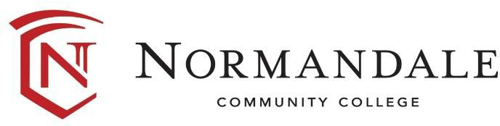
Normandale Community College is an affirmative action, equal opportunity educator and employer.
A MEMBER OF MINNESOTA STATE.

